

DATA STRUCTURE

Lab Report

Name: AdiL MaliK

Registration #: SEU-F16-161

Lab Report #: 04

Dated: 25-04-2018

Submitted To: Mr. Usman Ahmed

The University of Lahore, Islamabad Campus

Department of Computer Science & Information Technology

Experiment # 1

LINK LIST

Objective

To understand and implement the LINK LIS T .

Software Tool

1.DEV c++

- Theory

A linked list is a collection of components, called nodes. Every node (except the last node) contains the address of the next node. Thus, every node in a linked list has two components: one to store the relevant information (that is, data) and one to store the address, called the link, of the next node in the list. The address of the rst node in the list is stored in a separate location, called the head or rst

Linked list: A list of items, called nodes, in which the order of the nodes is determined by the address, called the link, stored in each node. The arrow in each node indicates that the address of the node to which it is pointing is stored in that node. The down arrow in the last node indicates that this link eld is NULL.

- Task

2.1 Procedure: Task 1

#include<i o s t r e a m >

#include<s t d i o . h>

1

#include<s t d l i b . h>

using namespace s t d ;

struct Nodef
int data ;

struct Node next ;

- ;

struct Node head ;

void I n s e r t ( int x )

f
struct Node temp=(Node ) m a l l o c ( s i z e o f ( struct Node ) ) ;

temp >data=x ;

temp >next=head ;

head=temp ;

g
void p r i n t ( )

f
struct Node temp=head ;

cout<<" L i s t i s " ;

while ( temp!=NULL)

f
cout<<" "<<temp >data ;

temp=temp >next ;

g

cout<<"nn" ;

g

int main ( )

f
head = NULL;

cout<<"how many numbers ? " ;

int n , i , x , y ;

c i n >>n ;

for ( i =0; i <n ; i ++)

f
cout<<"ENTER THE NUMBER"<<e n d l ;

c i n >>x ;

I n s e r t ( x ) ;

p r i n t ( ) ;

gg

2

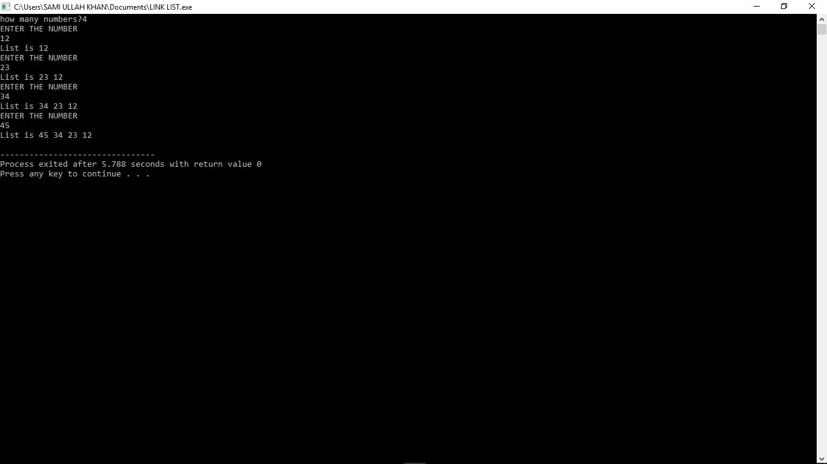

Figure 1: Time Independent Feature Set

- Conclusion

In this lab we learn about the application of link list and alo how it work and got the idea about the link list and perform them prectcaly on computer in c++

3

